Library Management System

Done by:
Karunya Darsi
CGO0158
PFS-ONE-002

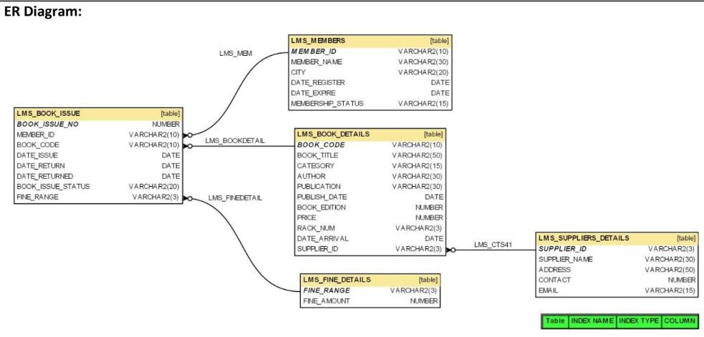

Task 1 : create all tables with suitable relations mentioned in above ER – Diagram. Task 2 : insert atleast 20 records in each table for better experience with queries.
- Write a query to display the member id, member name, city and membership status who are all having life time membership. Hint: Life time membership status is
“Permanent”.
select member_id, member_name, city, membership_status
from lms_members
where membership_status = 'permanent';
m001 | rahul | vijayawada | permanent
m003 | arjun | chennai | permanent
m005 | kiran | vijayawada | permanent
m007 | ravi | chennai | permanent
m009 | vamsi | vijayawada | permanent
m011 | suresh | hyderabad | permanent
m013 | nikhil | vijayawada | permanent
m015 | rohit | bangalore | permanent
m017 | manoj | chennai | permanent
m019 | ajay | delhi | permanent

- Write a query to display the member id, member name who have not returned the books. Hint: Book return status is book_issue_status =’Y’ or ‘N’.

select distinct m.member_id, m.member_name
from lms_members m
join lms_book_issue bi
on m.member_id = bi.member_id
where bi.book_issue_status = 'n';

- Write a query to display the member id, member name who have taken the book with book code ‘BL000002’.

select m.member_id, m.member_name
from lms_members m
join lms_book_issue bi
on m.member_id = bi.member_id
where bi.book_code = 'bl000002';

- Write a query to display the book code, book title and author of the books whose author name begins with ‘P’.

select book_code, book_title, author
from lms_book_details
where author like 'p%';

- Write a query to display the total number of Java books available in library with alias name ‘NO_OF_BOOKS’.

select count(*) as no_of_books
from lms_book_details
where category = 'java';

- Write a query to list the category and number of books in each category with alias name ‘NO_OF_BOOKS’.

select category, count(*) as no_of_books
from lms_book_details
group by category;

- Write a query to display the number of books published by "Prentice Hall” with the alias name “NO_OF_BOOKS”.

select count(*) as no_of_books
from lms_book_details
where publication = 'prentice hall';

- Write a query to display the book code, book title of the books which are issued on the date “1st April 2012”.
select bd.book_code, bd.book_title
from lms_book_details bd
join lms_book_issue bi
on bd.book_code = bi.book_code
where bi.date_issue = '2012-04-01';

- Write a query to display the member id, member name, date of registration, membership status of the members who registered before "March 2012" and membership status is "Temporary"
/*Q9*/
select member_id,
member_name,
date_register,
membership_status
from lms_members
where date_register < '2012-03-01'
and membership_status = 'temporary';

- Write a query to display the member id, member name, date of registration and expiry date of the members whose membership expiry date is before APR 2013.

select member_id,
member_name,
date_register,
date_expire
from lms_members
where date_expire < '2013-04-01';

